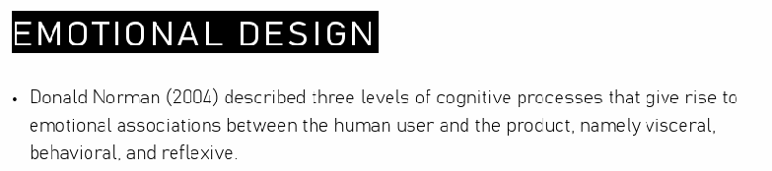

3 different levels that are relevant to create an association between the user and the technology.
- Visceral
- Behavioural
- Reflexive

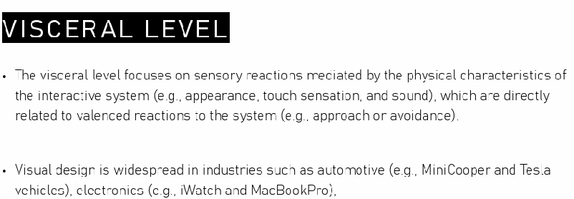
First consider the visceral level. Focus on sensory reactions mediated by the physical characteristics of the interactive systems.

Concern with physical picture.

Designer wanted to focus on some visual and physical feature of the object to have a positive effect on the user in an automatic way.

Let the object be beautiful from a perceptual point of view.

Adding something nice to the interface we are designing. All those aspect could have an impact on the perception that facilitate the interaction with this technology.

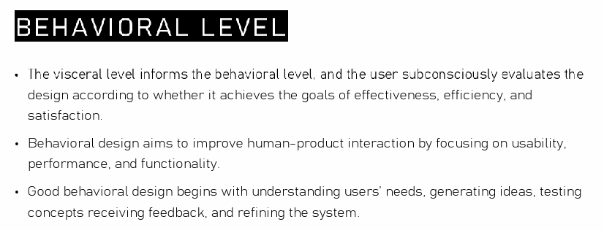

need to develop design efficient. We as users are able to evaluate the technology thanks to with we are able to archive what we want to archive.

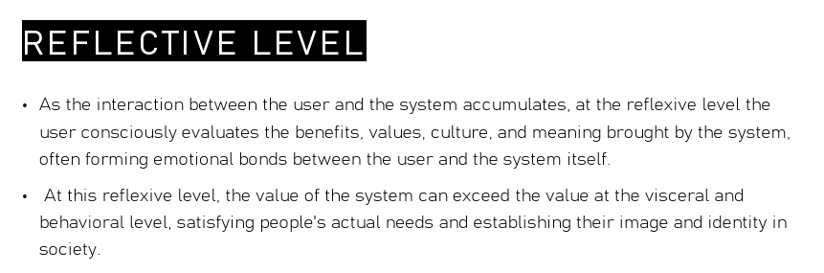

the mining inside a product could play a role. The user consciously evaluate the meaning wrote by the artificact and forming an emotional bound between the eprson and the product. If we design a system we have to consoder that product should be beautiful and elicit ineffective result

there are some social and cultural norm that guide teh interaction with the technology.

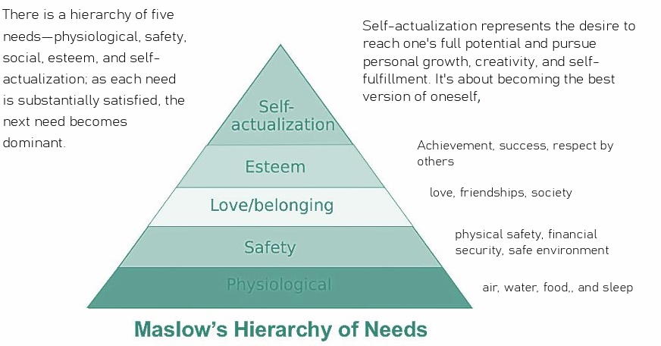

According to Maslow there is a hierarchy of 5 needs
- physiological needs
- safety needs
- love/belonging needs
- esteen needs
- self actualization needs

as each needs are safety the next need could become dominant.
After I get the physiological needs I can desire the safety needs.

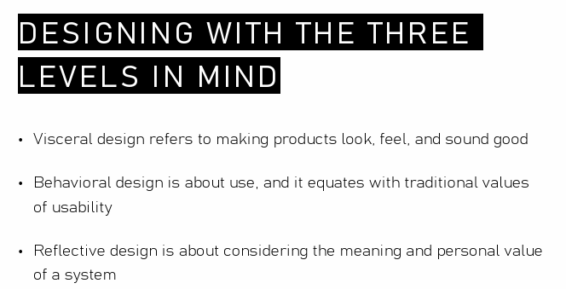

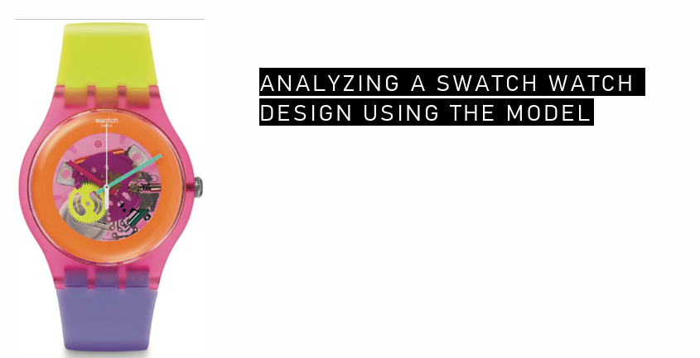

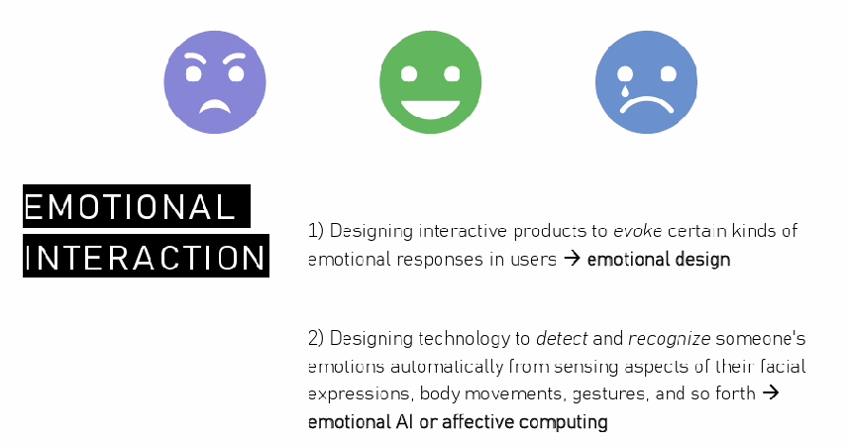

--25

--26
recognise pattern of emotions or dimensional model.

--27
we can collected different body signal (skin condasctat responses, ehart rate, how the face react to an emotion, speech/vocal data). All these body signal could signal an emotion

By recognising emotions and the detection of some emotionals patterns have been applied in several domains to gain the impact of affective computing was enormous in serval domains

--28
Which kind of systems has been used to collect physiological data? We can use cameras to detect changes in facial expressions

We can huse body sensors to collected phsiolocial signal

Can use some divides to collected information from voices (intonation, peach) when I have an emotion it changes

We can collect information from gesture

--29
I can collect all physiological data and usually I have to clean the data.

--30
face detection

many research in face detecting emotions.

Ekman introduces the idea that we show emotions though our face toroguh the activation of muscle and to build a specific emotion for eachemotion he developed a system (FACS) to measure facial activity to measure objective compojent of facial motions

the idea was to have a method to quantify emotions

PAPER 1
Social skills training using a virtual agent capable of reading facial expressions, speech and prosody while providing real-time verbal and nonverbal responses. It incorporates a virtual agent in the context of job interview training.

After the interaction MACH provides visual feedback on the user’s performance. Development based on 28 interviews sessions

result:
90 MIT undergraduates and weeklong trial. According to human experts students who interacted with MACH improved their performance. Students in the control group did not experience the same improvement. Post-experiment interviews found the experience informative and express interest in using MACH again in the future.

MACH uses technology to analzye facial expressions, speech and generate conversational bejaviours in real time. Offers the illusion of seeing, hearing and responding to the user

